**Beet Sprout**

| **Module Name** | | Detailed Information |  |  |  | **Step №** | **Action** | **Inputs** | **Expected Result** | **Test Result** |
| --- | --- | --- | --- | --- | --- | --- | --- | --- | --- | --- |
| **Test Case ID** | | automoto_01 |  |  |  | 1 | Click on a car on the main page |  | Page with a detailed information is loaded | Pass |
| **Tester Name** | | Kuro |  |  |  |  |  |  |  |  |
| **Test Case Description** | | To check opening a page with detailed information about car |  |  |  |  |  |  |  |  |
| **Prerequisites:** | | 1. Stable internet connection. |  |  |  |  |  |  |  |  |
| **Environmental Information** | | 1. OS: Windows 10  2. System: Laptop |  |  |  |  |  |  |  |  |
|  | |  |  |  |  |  |  |  |  |  |
| **Test Scenario** | Checking that after clicking on a car, a page with detailed information is opening | | | |  |  |  |  |  |  |

| **Module Name** | | Search |  |  |  | **Step №** | **Action** | **Inputs** | **Expected Result** | **Test Result** |
| --- | --- | --- | --- | --- | --- | --- | --- | --- | --- | --- |
| **Test Case ID** | | automoto_02 |  |  |  | 1 | In field “Марка” choose a brand of a car | Peugeot | The field “Марка” is filled | Pass |
| **Tester Name** | | Kuro |  |  |  | 2 | In field “Модель” choose a model of a car | 407 | The field “Модель” is filled | Pass |
| **Test Case Description** | | To check search with parameters “Марка”, “Модель” and “Рік від” |  |  |  | 3 | In field “Рік від” choose a minimal deployment year | 2008 | The field “Рік від” is filled | Pass |
| **Prerequisites:** | | 1. Stable internet connection. |  |  |  | 4 | Click on the “Поиск” button |  | The page with the results of the search is loaded | Pass |
| **Environmental Information** | | 1. OS: Windows 10  2. System: Laptop |  |  |  |  |  |  |  |  |
|  | |  |  |  |  |  |  |  |  |  |
| **Test Scenario** | Checking that after choosing parameters in the search field, a list of cars with these parameters is appeared | | | |  |  |  |  |  |  |

| **Module Name** | | Contact Information |  |  |  | **Step №** | **Action** | **Inputs** | **Expected Result** | **Test Result** |
| --- | --- | --- | --- | --- | --- | --- | --- | --- | --- | --- |
| **Test Case ID** | | automoto_03 |  |  |  | 1 | Click on a car on the main page |  | Page with a detailed information is loaded | Pass |
| **Tester Name** | | Kuro |  |  |  | 2 | Click on the button “Контакти продавця” |  | Page with contacts and detailed information is loaded | Pass |
| **Test Case Description** | | To check opening a page with contact information about car |  |  |  |  |  |  |  |  |
| **Prerequisites:** | | 1. Stable internet connection. |  |  |  |  |  |  |  |  |
| **Environmental Information** | | 1. OS: Windows 10  2. System: Laptop |  |  |  |  |  |  |  |  |
|  | |  |  |  |  |  |  |  |  |  |
| **Test Scenario** | Checking that after clicking on the button “Контакти продавця”, a page with contact information is opening | | | |  |  |  |  |  |  |

| **Module Name** | | Mode of transport |  |  |  | **Step №** | **Action** | **Inputs** | **Expected Result** | **Test Result** |
| --- | --- | --- | --- | --- | --- | --- | --- | --- | --- | --- |
| **Test Case ID** | | automoto_04 |  |  |  | 1 | Scroll down to the “Каталог за видами транспорту” section |  | The “Каталог за видами транспорту” section is on the screen | Pass |
| **Tester Name** | | Kuro |  |  |  | 2 | Choose the mode of transport “Автобудинки” |  | The list of subcategories is on the screen | Pass |
| **Test Case Description** | | To check redirect to the page of mode of transport |  |  |  | 3 | Choose the “Будинок на колесах” categorie |  | The page with the list of cars is appeared | Pass |
| **Prerequisites:** | | 1. Stable internet connection. |  |  |  |  |  |  |  |  |
| **Environmental Information** | | 1. OS: Windows 10  2. System: Laptop |  |  |  |  |  |  |  |  |
|  | |  |  |  |  |  |  |  |  |  |
| **Test Scenario** | Checking that after choosing mode of transport, user redirects to the mode’s page | | | |  |  |  |  |  |  |

| **Module Name** | | Detailed Information |  |  |  | **Step №** | **Action** | **Inputs** | **Expected Result** | **Test Result** |
| --- | --- | --- | --- | --- | --- | --- | --- | --- | --- | --- |
| **Test Case ID** | | automoto_05 |  |  |  | 1 | Scroll down to the “Каталог за регіонами” section |  | The “Каталог за регіонами” section is on the screen | Pass |
| **Tester Name** | | Kuro |  |  |  | 2 | Choose the region “Львів” |  | The page with the list of cars is appeared | Pass |
| **Test Case Description** | | To check redirect to the page of the region |  |  |  | 3 |  |  |  | Pass |
| **Prerequisites:** | | 1. Stable internet connection. |  |  |  | 4 |  |  |  | Pass |
| **Environmental Information** | | 1. OS: Windows 10  2. System: Laptop |  |  |  | 5 |  |  |  | Pass |
|  | |  |  |  |  |  |  |  |  |  |
| **Test Scenario** | Checking that after choosing region, user redirected to the region page | | | |  |  |  |  |  |  |

* LIST USERS - Незважаючи на те, що всього є дві сторінки з користувачами, запит з отримання інформації з 5-ої сторінки завершується з статусом 200

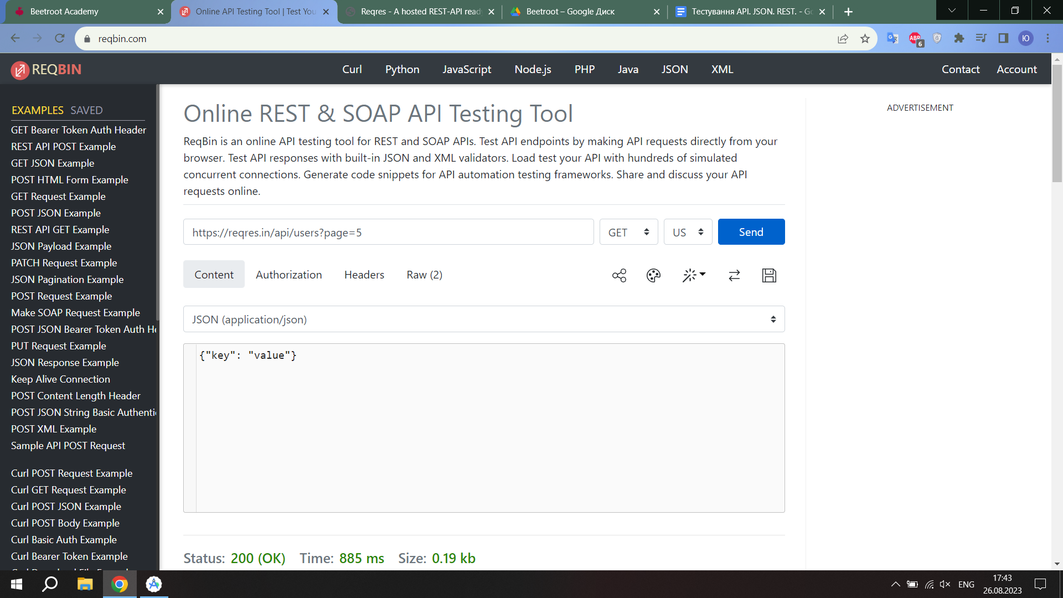

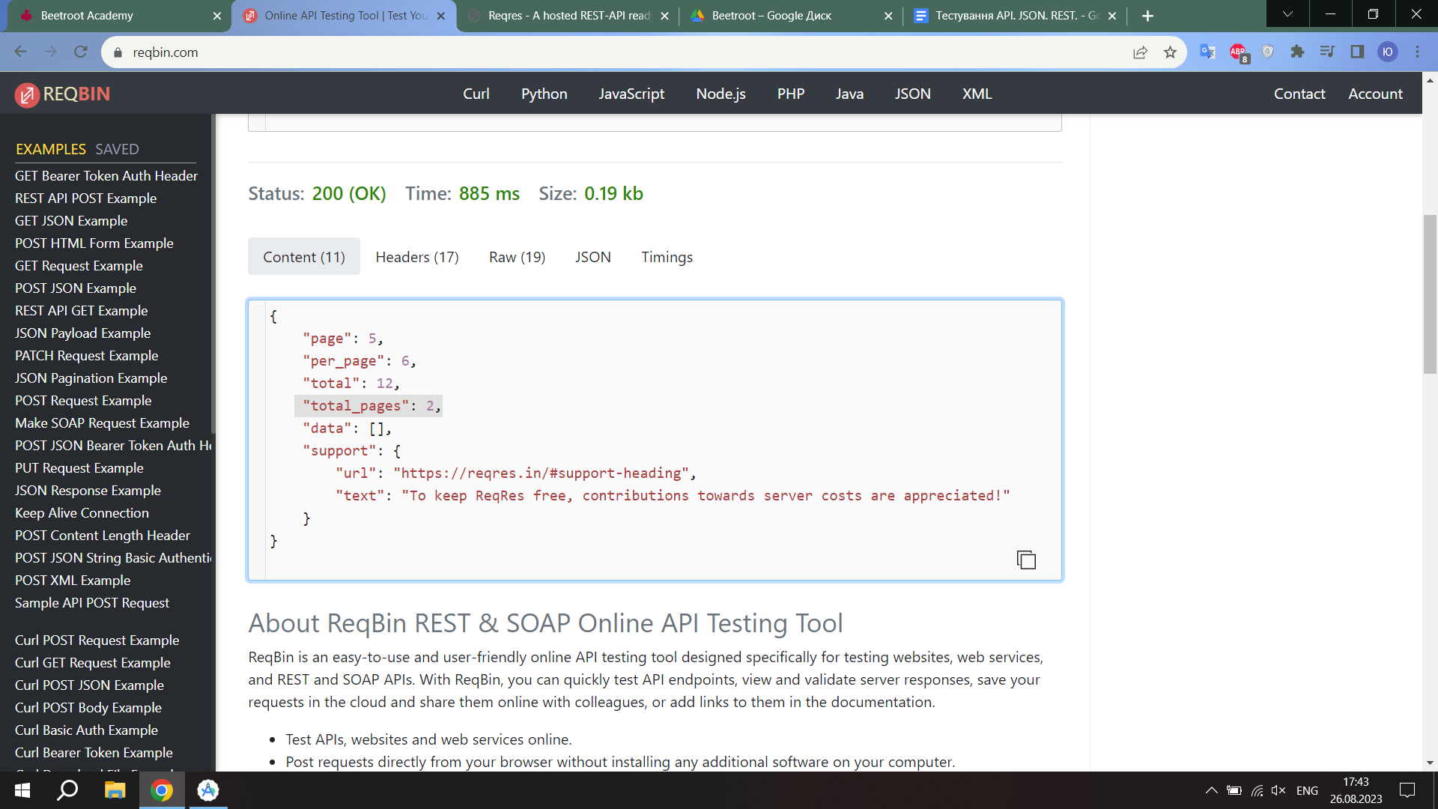

* SINGLE USER
* CREATE - Користувач створюється навіть якщо не введені данні  
  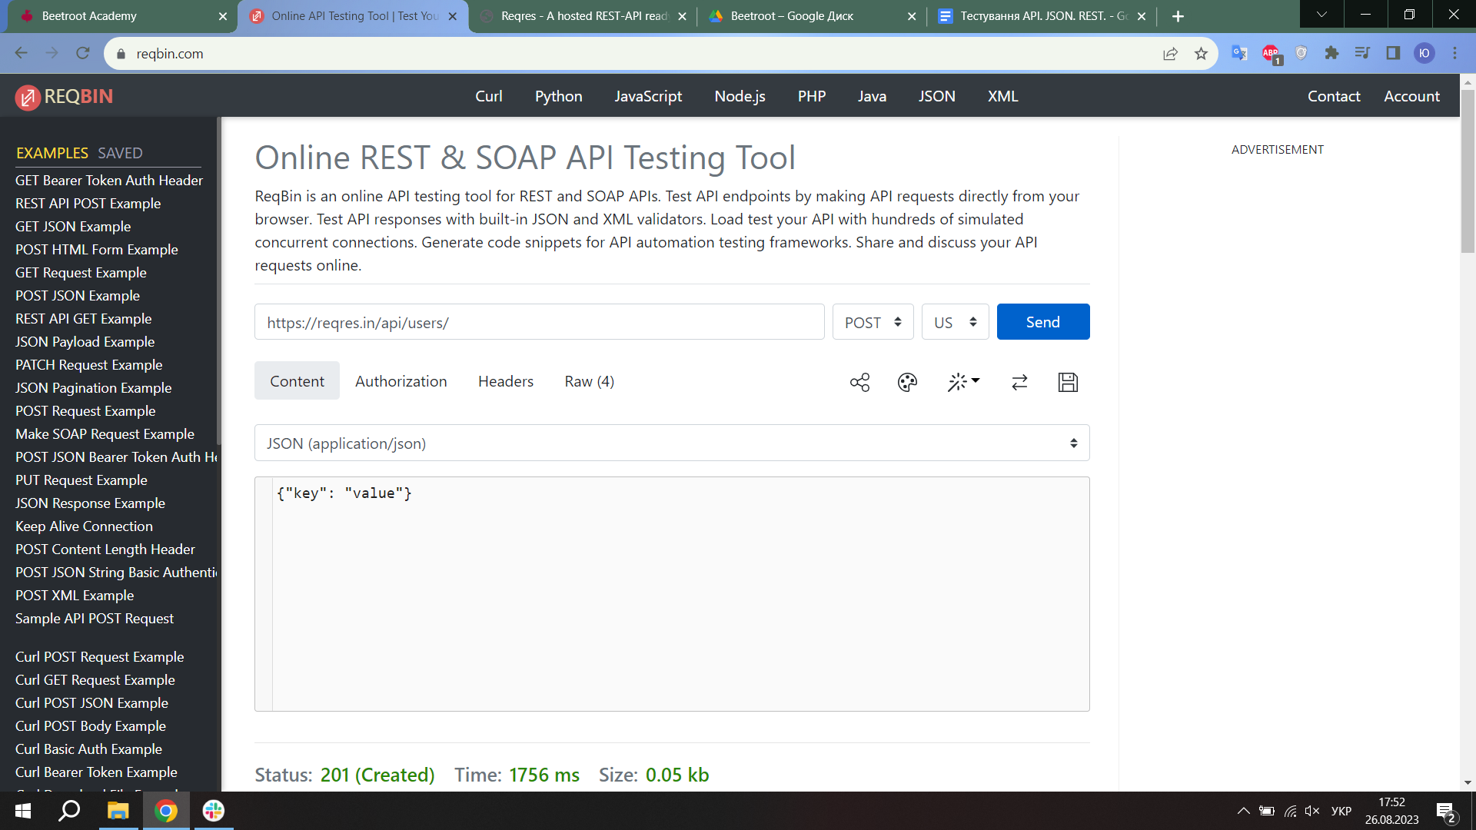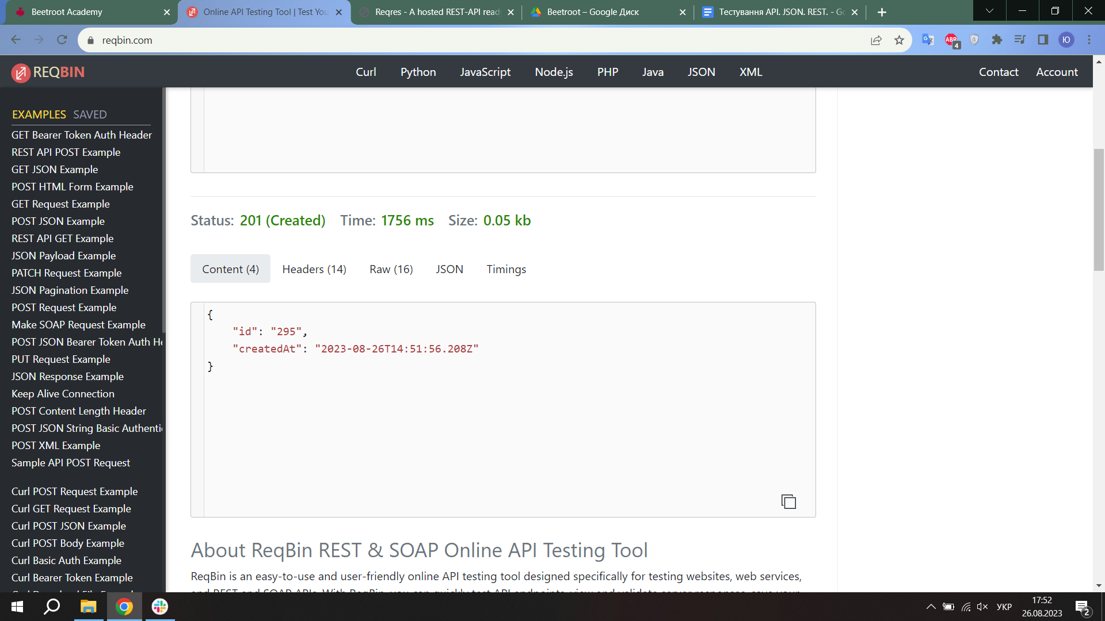
* UPDATE (PUT) - PATCH та PUT працюють однаково, хоч це і два різні методи
* UPDATE (PATCH) - PATCH та PUT працюють однаково, хоч це і два різні методи
* DELETE - Не впевнений наскільки це можна рахувати багом, але можна видалити не існуючого користувача  
  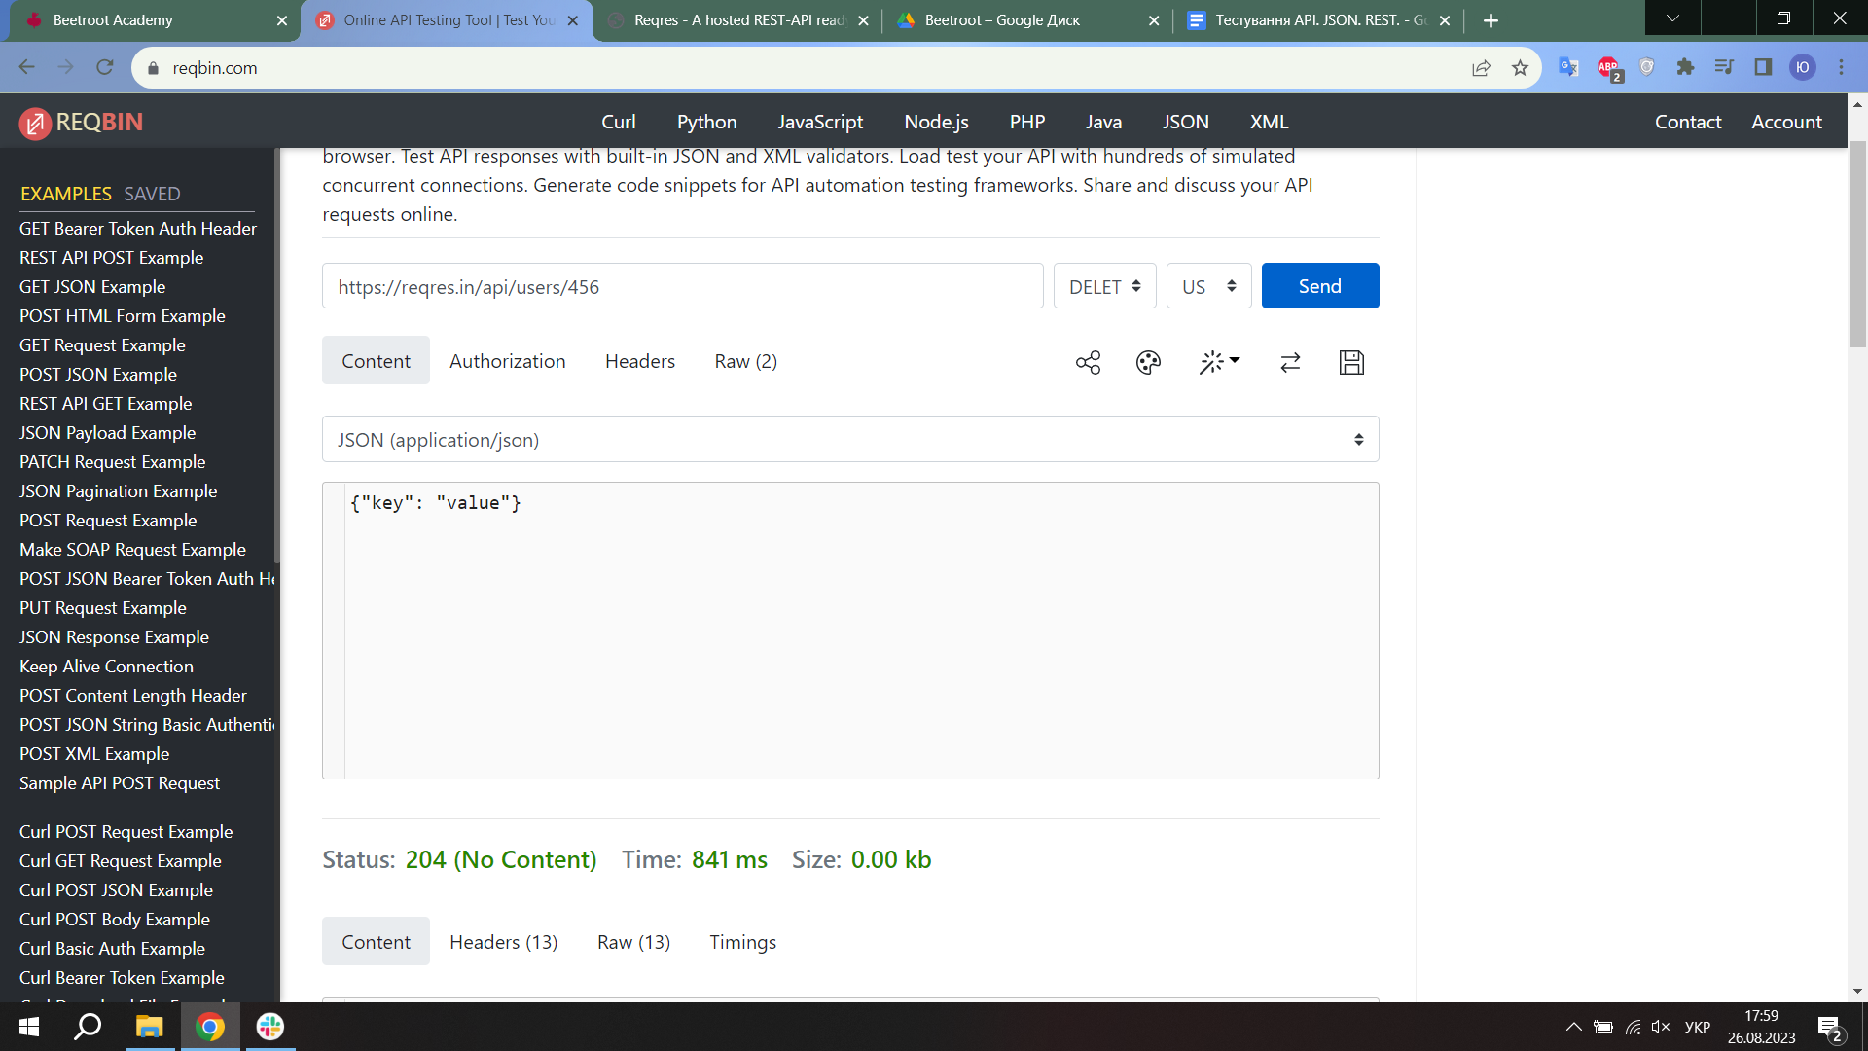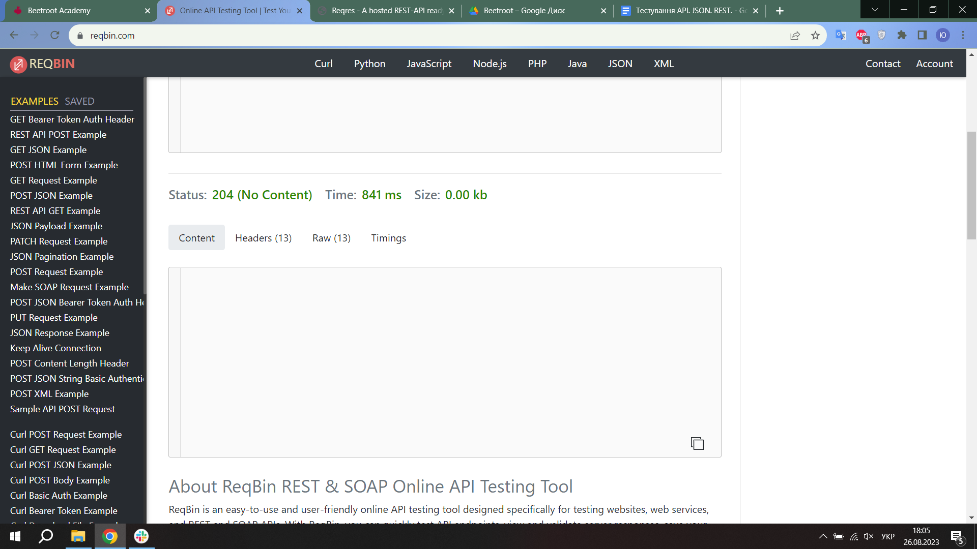
* REGISTER - SUCCESSFUL
* LOGIN - SUCCESSFUL